**Women of the 6888th**

**Central Postal Directory Battalion**

***Motto:*** *“No Mail, Low Morale”* ***Nickname****: “The Six-Triple Eight”*

**“…THERE IS NO PLEASURE IN ACHIEVEMENT, IF IT IS NOT SHARED.” LTC CHARITY ADAMS (EARLEY)**

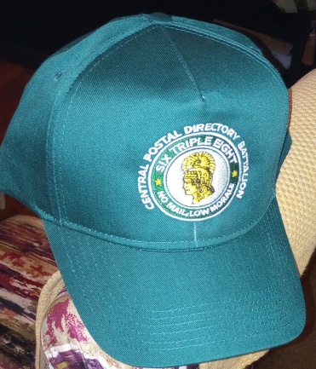

(The WAC colors are **Mosstone Green** and **Old Gold** Piping).

YES! I want to **help support the Women of the** **6888th Central Postal Directory Battalion** to raise **$17,500** to complete ***two planned post-6888th Monument actions:*****1st**- replace the current resin statue with a bronze version and **2nd**-erect a pedestal to list names located since the 6888th monument was dedicated on November 30, 2018.

**DONORS of $68.88 or more are entitled to one FREE 6888th Central Postal Directory Battalion ball cap. If you do not want a ball check NO____. *Note:*** *Will take at least 2 weeks after processing the donation for delivery*

Donation amount: ___$6.88 ____$8.88 ___$16.88

___$26.88 ____$38.88 **_*__$68.88*** _____OTHER

**IRS Requirement: If a company donates $250, or more please provide EIN. Your donation is** **Tax-Deductible.**

**SCAN THE QR CODE TO DONATE ONLINE**



Please make check or money orders payable to: the **National 9th and 10th (Horse) Cavalry Association (Pedestal Project)**

**Mail to: Buffalo Soldier Educational and Historical Committee   
 c/o 9701 NW 73rd Terrace, Weatherby Lake, MO 64152**

Your ADDRESS_______________________________________________________________

CITY____________________ STATE______ ZIP CODE **___ __ __ __ ___ + ___ ___ ___ ___**

Optional Phone: ____________ Optional email: _____________________________________

SSN/EIN, If applicable:__________________________________________________________

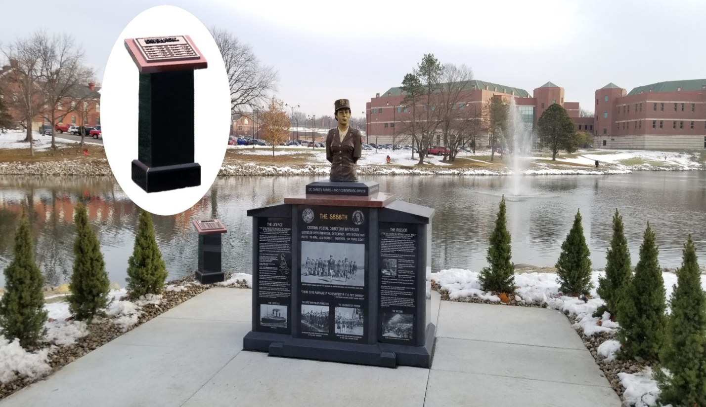 **Photo copyright Keith L. Pope----Statue: Master Sculptor Eddie Dixon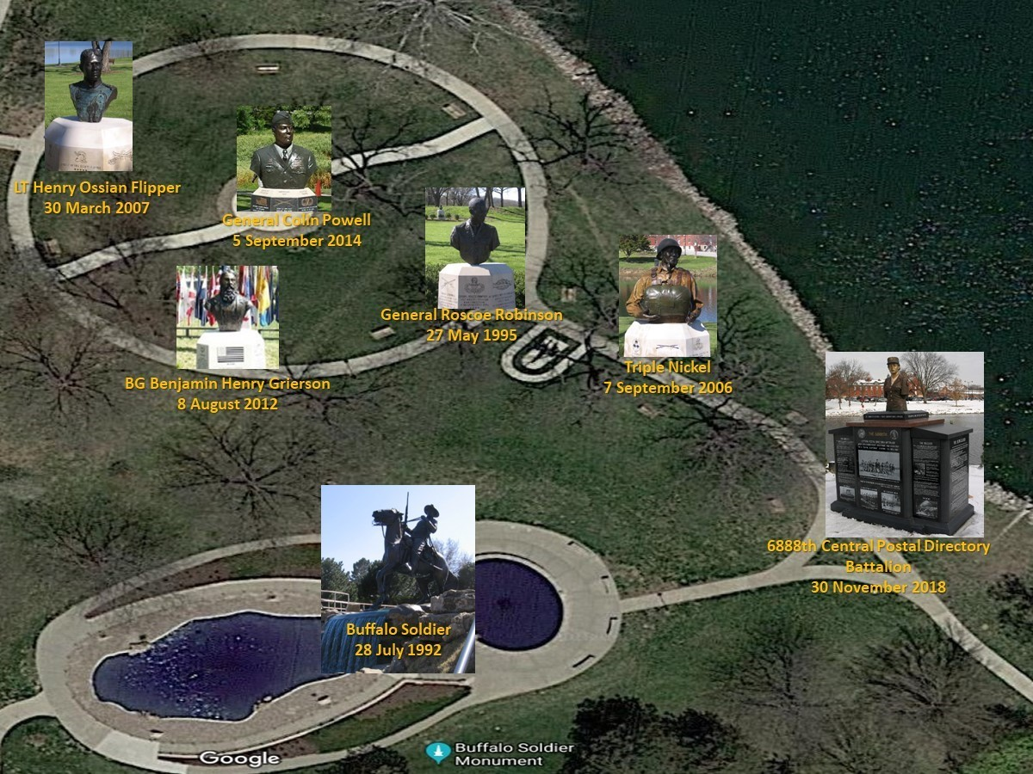 Buffalo Soldier Monument Park, FT. Leavenworth, KS  
Copyrighted. Photo created by Major (RET) Dominic Johnson, US Army**